Tutorial 3

CB.EN.U4CSE18502

HRIDHI SETHI

CSE A

4TH YEAR, BTECH CSE

# Activities table

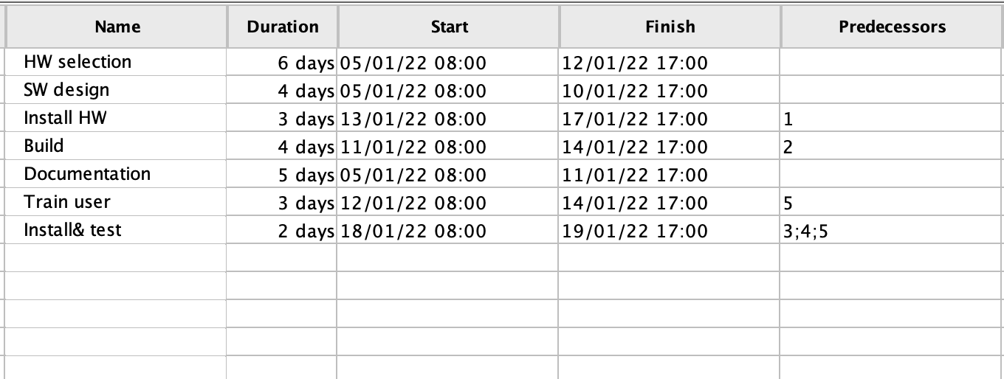

# Network diagram

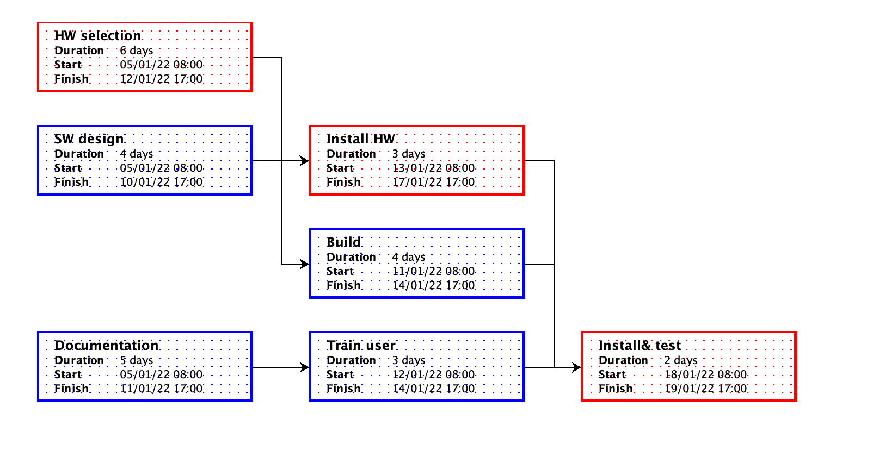

# Gantt chart

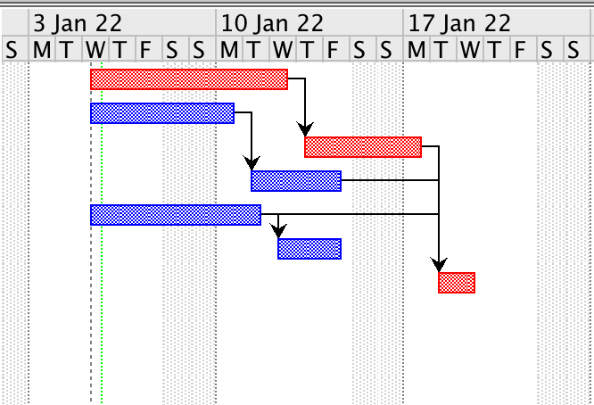

# Project finish date

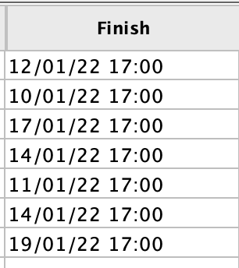

We assumed that project starts from 05/01/2022

So the finish date of project is 19/01/2022